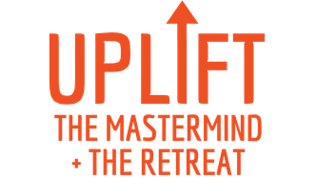

Dear [amazing boss’s name]:

You know I’m determined to accomplish _____ and _____ in the next year. While I’m feeling ambitious and driven, I would benefit enormously from some inspiration and new skills.

I’d love to enroll in UPLIFT: The Mastermind and Retreat, a coaching program and 2-day conference designed specifically for women in development.

I would come away with:
- Clear goals to truly move the needle with key donors this fiscal year
- A 90-day plan to jump-start that achievement
- Ideas to help us build the most vibrant culture here
- A renewed sense of purpose and resilience
- A community of high-achieving women to support my growth in this career

The Mastermind includes 90-minute Zoom workshops before the retreat to:
- Build Confidence: Overcome Imposter Syndrome
- Create Culture: Navigate Never-Ending Change
- Manage Self vs. Manage Time
- UPLIFT: The In-Person Retreat (8/25 & 8/26)
And another 90-minute workshop a week after the retreat to:
- Persist: Stay Accountable (follow up on my 90-day action plan)

This deeper dive into skills, mindset and implementation would make a real difference for me to plan purposefully and take massive action.

UPLIFT is facilitated by Generous Change, leaders of Fundraisers’ University and workshops for fundraising managers and academic leaders. I’m so excited about the opportunity to get precious time for reflection, planning and skill-building.

Tuition for the Mastermind and the conference in Phoenix August 25-26 is $2499. With your permission, I’d love to register?

Thank you so much for considering this investment in my growth here at _____!
I’m so grateful for your support.
[Your name]

