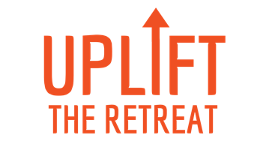

Dear [amazing boss’s name]:

You know I’m determined to accomplish _____ and _____ in the next year. While I’m feeling ambitious and driven, I would benefit enormously from some inspiration and new skills.

I’d love to attend UPLIFT, a two-day strategic planning and skill-building retreat just for women in development.

This year, it’s in Phoenix Aug 25-26. Enrollment is $1199 and breakfast and lunch are included both days.

I would come away with:
- Clear goals to truly move the needle with key donors this fiscal year
- A 90-day plan to jump-start that achievement
- Ideas to help us build the most vibrant culture here
- A renewed sense of purpose and resilience
- A community of high-achieving women to support my growth in this career

UPLIFT is facilitated by Generous Change, leaders of Fundraisers’ University and workshops for fundraising managers and academic leaders. I’m so excited about the opportunity to get precious time for reflection, planning and skill-building.

With your permission, I’d love to register for this conference?

Thank you so much for considering this investment in my growth here at _____!
I’m so grateful for your support.
[Your name]

